Source | Laboratoire des Applications Numériques (LAN)
Title | FSAN - Test plan for the 10th GPON Interoperability event hosted by LABORATOIRE DES APPLICATIONS NUMÉRIQUES (LAN)
Project | FSAN Interoperability Task Group
Authors | Vincent Buchoux, Thierry Doligez  Laboratoire des Applications Numériques  165 rue Yves Chauvin  Node Park Touraine  37310 Tauxigny - France  Phone : +33247432500  Fax : +33247432501  E-mail:  vincent.buchoux@lanpark.eu  thierry.doligez@lanpark.eu | 
Contributors | Régis Coat  Orange  E-mail: regis.coat@orange-ftgroup.com  Bertrand Le Guyader  Orange Labs  E-mail: bertrand.leguyader@orange-ftgroup.com  Alessandro Capurso  Telecom Italia  E-mail: alessandro.capurso@telecomitalia.it
Status: | Version 0.06
Abstract: | This document describes the tests which will be implemented for the 10th FSAN test event within the scope of GPON interoperability testing.
Tests event n°10

GPON tests definition document
Version V0.06 date: November 8, 2026

SUMMARY

Introduction 5
1 Participants 6
2 Mandatory/Optional test cases 7
3 Test Environment Overview 8
LAN Facility Description 8
OLT Test positions 10
ONU Room 12
Test Equipment and Components 12
Testing Aspects 12
4 Prerequisites 13
5 GPON Analyzer tools 13
6 ONU_{OLT} Setup 14
7 Official Test Cases 15
7.1 Principle 15
7.2 Preliminary test cases 16
7.2.1 TC1 – PRELIM – Provisioning using Registration ID method (correct Reg-ID case) 17
7.2.2 TC2 – PRELIM – VLAN Architecture N:1 bridge model 19
7.3 Multicast/IGMP tests cases 22
7.3.1 Common Test Pre-Conditions : Multicast Flows Definition 22
7.3.2 TC3-4 – MCast – Availability of Multicast traffic on the ONUs and Zapping tests 23
7.3.3 TC5 – Mcast – IGMP Channel Conditional access (allowed channels) 26
7.3.4 TC6 – Mcast – Channel Conditional access (Limited number of channels) 28
7.3.5 TC7 – Mcast – IGMP Channel Conditional access (Bandwidth) 30
7.3.6 TC8 – Mcast – IGMP counters 32
7.4 Optional tests cases 34
7.4.1 TC9 – OPT – ONU software upgrade 34
7.4.2 TC10 – OPT – MIB and alarm Synchronisation 36
7.4.3 TC12 – OPT – Provisioning using Registration ID method (wrong Reg-ID case) 38
8 Blindfold pairing tests 40
8.1 Principle 40
8.2 Blindfold pairing test case 41
8.2.1 BF - Availability of Multicast traffic on the ONUs and Zapping tests 41
9 Event agenda and tests schedule 43
9.1 Official test pairings 44
9.2 Blindfold test pairings 44
10 Expected result metrics 45
Annex 46
Annex 1: Template for test cases 46

Revision History

Draft | Date | Description
0.01 | February 10, 2010 | Initial draft
0.02 | February 16, 2010 | list of participants updated  Pre-requisites section updated
0.03 | February 23, 2010 | list of participants updated  comments from broadlight on v0.02 addressed  Multicast Flows Definition completed  TC10 - OPT – MIB and alarm Synchronisation added
0.04 | March 2, 2010 | list of participants updated  comments from broadlight and ECI on v0.03 addressed  TC3 and TC4 (§5.2.2 and §5.2.3 merged for simplification purpose.  TC9 included
0.05 | March 4, 2010 | MCAST tests conditions have been updated with more details when needed  All test criteria have been modified and defined with a “Pass” criterion  OLT proxy IP address has been specified  Blindfold pairing tests have been described  Official and BF test pairings planning have been defined  TC11 on Provisioning using Registration ID method (wrong Reg-ID case) has been added in the optional tests section
0.06 | March 16, 2010 | Time gate for prelim TCs changed to 1h  Backup session definition added  TC11 changed into TC12  TC10 splitted in 2 TCs (TC10 and TC11)  Blindfold pairing : TC configuration & needed CLI commands  Result metrics file included  Test Pairings schedule updated  Test Event agenda updated

Introduction

This document is meant to fully describe the test event test plan (including test cases to be used), the test sequence and the enabling test devices and tools available.

Each vendor attending the test event should be able to use the information contained in this document to evaluate, and if necessary develop, the capability of its solution to match the intended interoperability assessment tests. This document is also intended to specify the materials and equipment that the participants should bring to the test event.

All feedback is welcome to consolidate the tests proposed.

This test eventtest event is dedicated to verify that the ITU-T OMCI Implementers' guide version 1 (ITU-T G.984.4Impl) and Broadband Forum TR-156 allow "plug and play" GPON interoperability. All the test should be completed by participants in conformance with ITU-T G.984.4Impl and Broadband Forum TR-156.

An official pairing is declared as successful only if developments are 100% compliant with these two documents.

Mike Shaffer who is the OISG coordinator will not be present during the test week but offered his remote support as a referee. If vendors do not agree on a common OMCI model, he will analyze the situation and solve it by saying which OMCI model is the right one or if there is something missing in the OMCI Implementers' guide, he will take the action point to solve the issue.

Participants are requested to be in the test event rooms all the week.

Participants

 | Vendors | OLT | ONU | Status
1 | Alcatel-Lucent | X | X | registered
2 | Broadcom |  | X | registered
3 | Broadlight |  | X | registered
4 | Cambridge |  | X | registered
5 | Comtrend |  | X | registered
6 | ECI | X | X | registered
7 | Huawei | X | X | registered
8 | Occam Networks | X |  | registered
9 | PMC Sierra |  | X | registered
10 | Tecom |  | X | registered
11 | ZTE | X | X | registered
 | Observers
1 | MT2 | GPON Analyzer |  | registered
2 | Tracespan | GPON Analyzer |  | registered
3 | Telnet | GPON Analyzer |  | registered
4 | LAN | ITL |  | Hosting Lab
5 | Orange Labs |  |  | Technical support
6 | OISG / Mike Shaffer |  |  | Remote support

Mandatory/Optional test cases

Test  case n° | Test case | Mandatory | Optional
TC1 | PRELIM – Provisioning using Registration ID method (correct Reg-ID case) | X
TC2 | PRELIM – VLAN Architecture N:1 bridge model | X
TC3-4 | MCAST – Availability of Multicast traffic on the ONUs and Zapping tests | X
TC5 | MCAST – Channel Conditional access (allowed channels) | X
TC6 | MCAST – Channel Conditional access (Limited number of channels) | X
TC7 | MCAST – Channel Conditional access (Bandwidth) | X
TC8 | MCAST – IGMP counters | X
TC9 | OPT – ONU software upgrade |  | X
TC10 | OPT – MIB Synchronisation |  | X
TC11 | OPT – Alarms Synchronisation
TC12 | OPT – Provisioning using Registration ID method (wrong Reg-ID case) |  | X

Test Environment Overview
This section highlights the test environment being provided by LAN for the Test Event, including the facilities, test positions, test equipment, and any required ancillary support equipment.

LAN Facility Description
A sample layout of the test space is provided below.

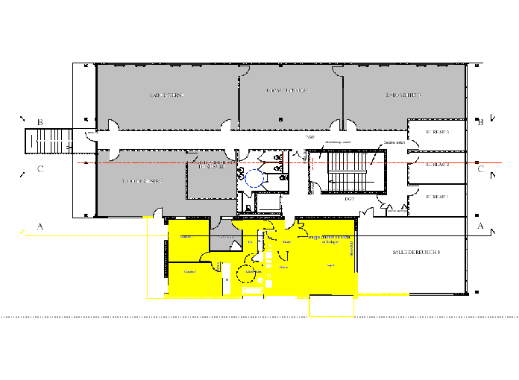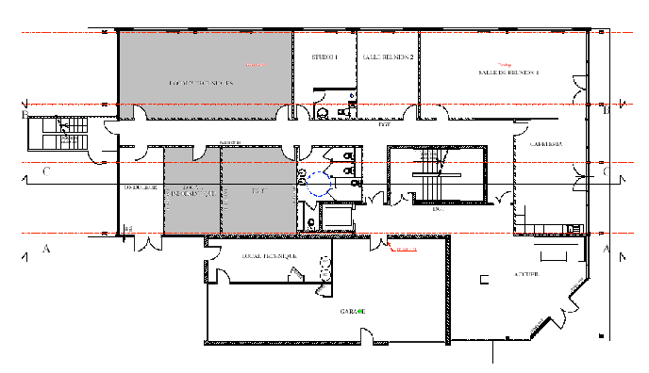
OLT Lab #2
(62m²)
OLT Lab #3
(45m²)
ONU Room
(58m²)
OLT Lab #1
(48m²)
Office
(21m²)
Meeting
(12m²)
Ground floor
1st floor
Cafeteria
Figure 1: Test Labs Layout
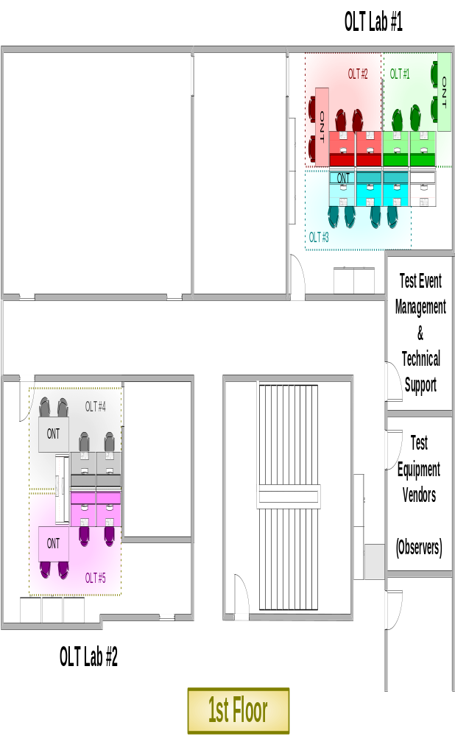

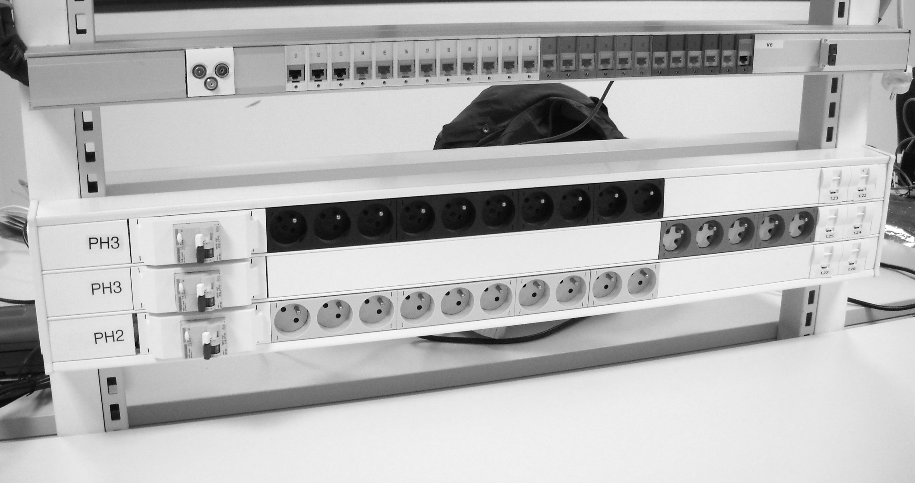
Figure 2: OLT Test Positions Layout

OLT Test positions

The test space consists of 5 “OLT test work positions” dispatched within 2 lab rooms (OLT Lab 1, OLT Lab 2).

- Each test position consists of three tables:
- one for the OLT vendor
- one for the ONU vendor involved in the active session
- one for DUTs and test equipments

- Provided by hosting lab :
  - 1 x 1by4 splitter
  - single mode fibers
    - 2 x SC/APC – SC/APC
    - 1 x SC/PC – SC/APC
    - 1 x dual fiber LC/PC –SC/PC
    - 1 x dual fiber SC/PC – SC/PC
    - 1 x dual fiber LC/PC – LC/PC
  - 3 x adapters SC/APC
  - 1 x fixed 5dB attenuator (SC-APC)
  - 1 x fixed 10dB attenuator (SC-APC)
  - 2 x RJ45 Ethernet cable (3 m)
  - 1 x 5 ports HUB

- Electrical Service: Electrical service in the form of 220 Vac, 50 Hz (16 amp max) service will be provided to each test positions. Two power strips of 10 power outlets each (Type E socket) are provided per test position. Vendors are advised to bring additional power strips if needed.

- Vendors requiring other power sources (including DC) have to bring the appropriate transformation equipment, e.g. electrical adaptors to type E sockets and power 48V converters.

- Data Communications/Internet: 802.11 wireless (VPN capable) Internet access will be provided. Connection information will be supplied at the start of the test event.

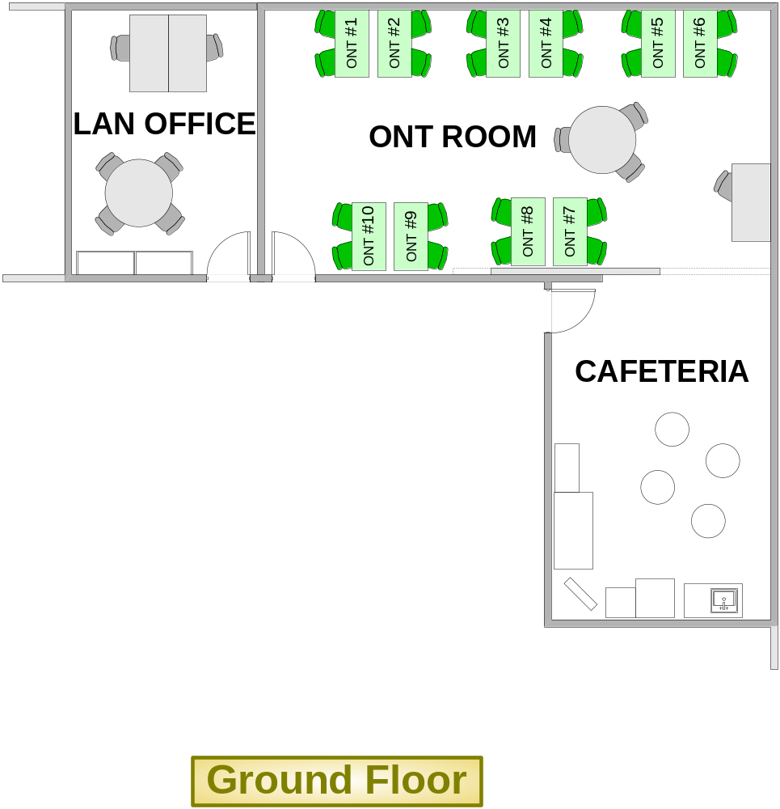

Figure 3: ONU Positions Layout

ONU Room
A meeting room which can host up to 24 attendees will be dedicated to ONU participants. The ONU position layout is defined as follows :

- A 70cm by 140cm table for 2 persons, with 6 Type E (2P+T) electrical sockets (220V, 50Hz, outlets adaptors are not provided) with maximum power consumption of 4 amp per table.

- Data Communications/Internet: 802.11 wireless (VPN capable) Internet access will be provided. Connection information will be supplied at the start of the test event.

In addition to the facility described above, the following will be available:
- Network Printer
- Photocopy and fax
- PC with video projector for Test Pairing tracking and Test Results collecting via an electronic “drop-box”.
- Full service cafeteria

Test Equipment and Components
OLT vendors are requested to provide, at a minimum, their own Ethernet data generator/traffic analyzer. This is intended to eliminate “bottlenecks” caused by the sharing of common test equipment/test equipment operators. OLT vendors are expected to be familiar with the operation of any test equipment they provide, including having test equipment scripts pre-defined to allow the efficient execution of any mandatory test cases specified in this document.

The Ethernet tester has to be able to fit the entire test plan (VLAN architecture, Multicast streams, IGMP).

Testing Aspects
Participants providing both OLT and ONU equipment to the Test Event are expected to provide adequate engineering support to allow both equipment types to be concurrently engaged in testing (at least, one specific engineer per equipment and a maximum of 2).

All test platforms must support OMCI-based provisioning. ONU platforms that require configuration through locally issued commands or scripting (as a substitute for processing OMCI-based commands) are NOT eligible for this event. It is assumed GTC layer functionality of test platforms are stable and mature.

Prerequisites
The following recommendations are addressed to OLT vendors :

- It is recommended for OLT vendor participants to implement the test cases proposed in the current test plan and to perform preliminary testing on their OLT solution prior to the test event using arbitrary ONUs of their choice (called ONU_olt in the sequel).

- To this end, the OLT suppliers are invited to fill in advance some result metrics files involving their own ONU and proivde these results by the beginning of the test event

- OLT suppliers are also requested during the first day of the test event to test with their own ONUs that the test setup proposed within the test plan and implemented by the OLT participant is operational

- ONU_{OLT} must be always connected during all test sessions and traffic must be running between OLT and ONU_{OLT}. (cf paragraph 5)

GPON Analyzer tools

GPON analyzer manufacturers are registered as observers during the test event. They may provide support during the test sessions w.r.t. the following rules:

- One GPON analyzer manufacturer will be invited by the Lab technical manager to join one specific blindfold test session.

- During the official test sessions, OLT and ONT vendors may agree to invite one GPON analyzer manufacturer of their choice depending on its availability.

ONU_{OLT} Setup

Each OLT vendor has to provision an ONU with the following architecture (N:1 bridge model, p bit mapping only). This ONU will be called along all the test event the ONUOLT. The ONU start up can be done according to the serial number method or the registration ID mechanism.

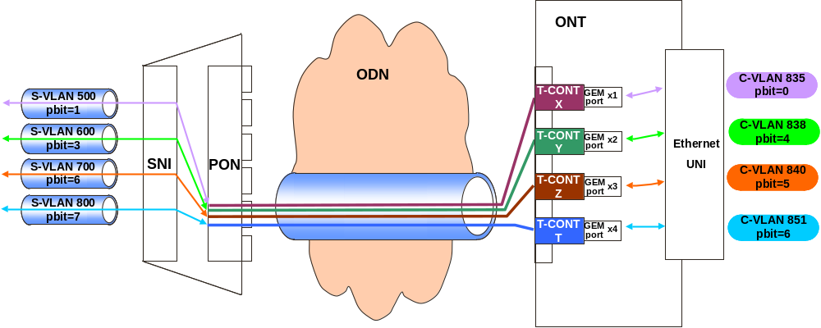
During all the session, Ethernet traffic of at least 1Mbits/s must be generated on each VLAN

Official Test Cases

Principle
The content of this test plan is focusing on the support of Multicast streams and on the correct handling of IGMP requests, and addresses typical functionalities such as :

- Availability of Multicast traffics on different ONUs
- Zapping Channel tests
- Channel Conditional access (allowed channels)
- Channel Conditional access (Limited number of channel)
- Channel Conditional access (Bandwidth)
- IGMP counters

The following test setup will be used

OLT
ONU_{3rd}
ODN B+
(attenuators
,
fiber
…
)
Ethernet
tester
ONU_{OLT}
Figure 4: Tests infrastructure

* ETHernet Tester shall be provided by the OLT vendor along with the required scripts and configuration that implement the test cases.
* All configurations will be realized using PLOAM/OMCI standardized messages.
* All configurations must be 100% compliant with the ITU-T OMCI Implementers' guide.
* No local actions on the ONU are allowed (except for Registration ID provisioning method).
* ONU equipped with multiple UNI interfaces must be using only one UNI interface during the test event.
* VLAN manipulations including Ethertype modifications location must be compliant with the description given in TR-156 (for example, VLAN manipulations at the ONU and not at the OLT for N:1 VLAN architecture)

Preliminary test cases

GATE: 60 minutes maximum

These preliminary test cases must be handled in a maximum of 60 minutes.

Backup session

If the 1h gate is reached without having the ONT ranged or without having the prelim test cases completed successfully, one of the vendors involved in the pairing can request to stop this active pairing session. Stopping the active pairing will be decided either with the agreement of the other vendor, or, if the other vendor does not agree with this request, the decision will be done in agreement with the Lab technical manager after evaluation of the situation. With the agreement of both vendors, the pairing could also continue.

In case an active pairing is stopped, the involved OLT will restart a pairing session with another ONT. The new ONT will be chosen by the Lab technical manager in a specific waiting list.

Additionnal session

Vendors who finish their sessions earlier, can start additional unofficial pairings and shall refer to the Lab technical manager to pick up a new ONT in the specific waiting list.

TC1 – PRELIM – Provisioning using Registration ID method (correct Reg-ID case)
ONU Provisioning according to the registration-ID (correct Reg-ID case)
Test Name | ONU Provisioning according to the registration-ID (correct Reg-ID case)
Test Definition ID
Reference Document | - BBF TR-156 Section 7.2  - ITU-T G. 984.3 Section 10 and Annex A.6  - ITU-T G.984.3 Amd1 Sections 2.2 and 2.3
Test Type | Interoperability
Test Status | Mandatory
Unit Under Test | OLT and ONU
Requirement(s)  Description | ITU-T G.984.3 Amd1:  - Sections 2.2 and 2.3, test of the ONU activation according to the registration-ID
Test Objective | The purpose of this test is to verify:  - that the ONU can reach the state O5 using the registration-ID mechanism  - the OMCC is established and activated when the correct Reg-ID is confirmed by the ONU
Test Configuration | Test Setup:  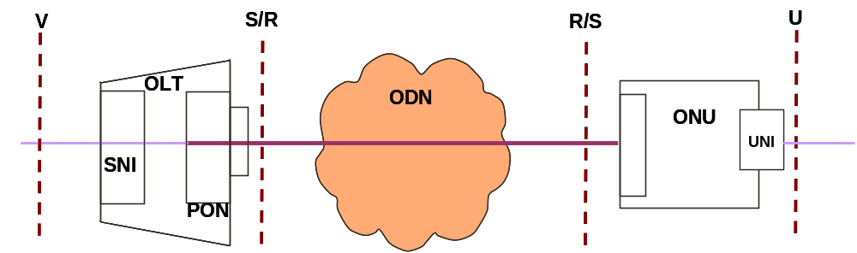  Preconditions:  - The OLT MUST be compliant with the requirements WT-247 R-151and R-155 (cf. dedicated OLT and ONU conformance tests),  - The ONU MUST be compliant with the requirement WT-247 R-152 (cf. dedicated OLT and ONU conformance tests)  - ONU_{OLT} has to be connected and traffic has to be generated on it  - The ONU is always powered on  Test Conditions:  - A remote access (CLI or EMS) to the OLT MUST be available
Test Procedure | - Pre-provision the ONU_{3rd} with the dedicated registration-ID at the OLT  - Via a local interface, enter at the ONU the correct registration-ID  - Connect the ONU_{3rd} to the ODN, which shall range after 30 s [time reference defined in the ITU-T Serie G, Supplement 46]  - Wait for and check that registration-id is confirmed with correct value  - Send from the OLT a Get ONT-G message towards the ONU connected to the OLT and check ONU answers back
PLOAM / OMCI Procedure Details | 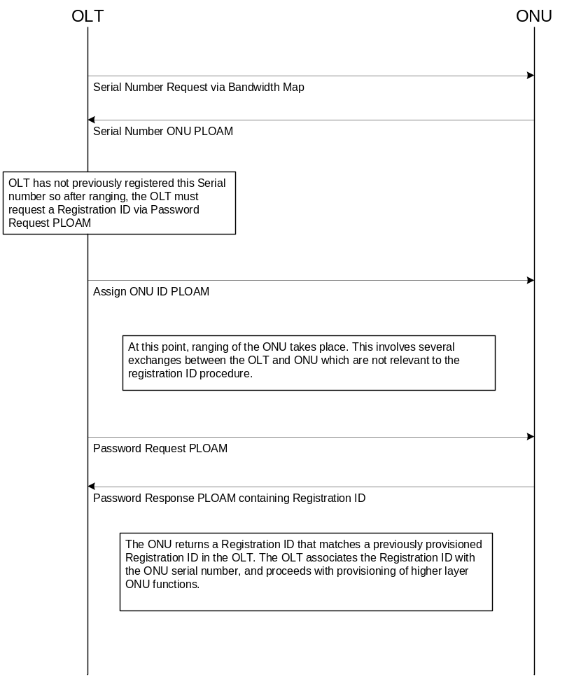
Pass/Fail Criteria | The test is "PASS":  - If O5 state is achieved and  - If the correct reg-ID is sent by the ONU and  - If the ONU answers successfully to a Get ONT-G message
Remarks

TC2 – PRELIM – VLAN Architecture N:1 bridge model

VLAN Architecture N:1 bridge model
Test Name | VLAN Architecture N:1 bridge model
Test Definition ID | tbd
Reference Document | Section 5.1.1 of TR-156 and ITU-T G.984.4 Implementers' Guide
Test Type | IOP
Test Status | Mandatory
Unit Under Test | OLT & ONU
Requirement Description | tbd
Test Objective | This test verifies that data flows are correctly forwarded on the GPON system using a N:1 bridge model and p bit mapping only, with different VID and different pbit (VID and pbit translation)
Test Configuration | Test setup:  Test preconditions:  - ONU_{OLT} has to be connected and traffic has to be generated on it  Test conditions:  All provisioning and management process between the OLT and the ONU must be fully compliant with ITU-T G.984.4 OMCI Implementers' Guide version 1 (or 2)  More specifically, the test assesses the GPON system capability to support a VLAN architecture based on the following description:  - On the aggregation network side, only one level of VLAN is involved  - Each flow on the customer network side is 802.1Q tagged  - Translation of the VID value: C-VID must be translated to S-VID in the upstream direction and the S-VID to C-VID in the downstream one  - Translation of the p-bit value: C-p-bit must be translated to S-p-bit in the upstream direction and S-p-bit to C-p-bit in the downstream one.  - 1 p-bit value per GEM port  - One GEM port per T-CONT  - Each T-CONT is associated to one specific p-bit value  On the ONU side, only one UNI interface is involved
Test Procedure | - Ethernet generator / analyzer is used  - Simultaneous transmission with all VLAN (835, 838, 840, 851)  - Use the OMCI commands to setup the entire configuration from the OLT to the ONU described in above Figure  - Create a connection between the OLT and the ONU with a C-VID identifier (C-VID=xx) and C-p-bit identifier (p-bit = n) and a S-VID identifier (S-VID=yy) and S-p-bit identifier (p-bit = m).  - Step 1: Define and send following frames (upstream direction)  - Verify that frames below are received on SNI port with the S-VID ≠ C-VID, and S-p-bit ≠ C-p-bit.  - Step 2: Define and send following frames (downstream direction)  - Verify that frames below are received on UNI port with the C-VID ≠ S-VID, and C-p-bit ≠ S-p-bit.  - Verify that these flows use the correct GEM ports / T-CONTs  - Verify with a GPON Analyser that the VLAN manipulation is done at the ONU  - Verify that no traffic interruption happened on the ONU_{OLT}
   | Dst Mac Address | Src Mac Address | C-VID | C-p-bit | Data
  Frame 1 | 00-00-00-00-00-11 | 00-00-00-00-00-01 | 835 | 0 | XXXXXX
  Frame 2 | 00-00-00-00-00-12 | 00-00-00-00-00-02 | 838 | 4 | XXXXXX
  Frame 3 | 00-00-00-00-00-13 | 00-00-00-00-00-03 | 840 | 5 | XXXXXX
  Frame 4 | 00-00-00-00-00-14 | 00-00-00-00-00-04 | 851 | 6 | XXXXXX
   | Dst Mac Address | Src Mac Address | S-VID | S-p-bit | Data
  Frame 1 | 00-00-00-00-00-11 | 00-00-00-00-00-01 | 500 | 1 | XXXXXX
  Frame 2 | 00-00-00-00-00-12 | 00-00-00-00-00-02 | 600 | 3 | XXXXXX
  Frame 3 | 00-00-00-00-00-13 | 00-00-00-00-00-03 | 700 | 6 | XXXXXX
  Frame 4 | 00-00-00-00-00-14 | 00-00-00-00-00-04 | 800 | 7 | XXXXXX
   | Dst Mac Address | Src Mac Address | S-VID | S-p-bit | Data
  Frame 1 | 00-00-00-00-00-01 | 00-00-00-00-00-11 | 500 | 1 | XXXXXX
  Frame 2 | 00-00-00-00-00-02 | 00-00-00-00-00-12 | 600 | 3 | XXXXXX
  Frame 3 | 00-00-00-00-00-03 | 00-00-00-00-00-13 | 700 | 6 | XXXXXX
  Frame 4 | 00-00-00-00-00-04 | 00-00-00-00-00-14 | 800 | 7 | XXXXXX
   | Dst Mac Address | Src Mac Address | C-VID | C-p-bit | Data
  Frame 1 | 00-00-00-00-00-01 | 00-00-00-00-00-11 | 835 | 0 | XXXXXX
  Frame 2 | 00-00-00-00-00-02 | 00-00-00-00-00-12 | 838 | 4 | XXXXXX
  Frame 3 | 00-00-00-00-00-03 | 00-00-00-00-00-13 | 840 | 5 | XXXXXX
  Frame 4 | 00-00-00-00-00-04 | 00-00-00-00-00-14 | 851 | 6 | XXXXXX
OMCI Procedure Details | n/a
Pass/Fail Criteria | Test is “Pass” if flows are correctly forwarded on the GPON system.  Correctly means "as described in section "Test Procedure".
Remarks

Multicast/IGMP tests cases

In this section, no unicast traffic is generated on the ONU_{OLT} except IGMP and multicast traffic which are required during the following tests cases.

Common Test Pre-Conditions : Multicast Flows Definition

  - Channels A, C, D, E are allowed on the ONU_{3rd}
  - Channels A, B, C, D, E are allowed on the ONU_{OLT}
  - Channel A, B, have a bandwidth of 12Mbit/s each
  - Channel C, D have a bandwidth of 4Mbit/s each
  - Channel E has a bandwidth of 16Mbit/s

IGMP version is V2

The following Multicast group definition must be applied on the OLT side and transmitted by the OLT on the ONU using the Manage Entity “MULTICAST OPERATION PROFILE” (attribute : dynamic access control list table).
:

IPTV Channels | A | B | C | D | E
IP Multicast group | 234.0.4.1 | 234.0.4.2 | 234.0.4.3 | 234.0.4.4 | 234.0.4.5
MAC Multicast group | 01:00:5E:00:04:01 | 01:00:5E:00:04:02 | 01:00:5E:00:04:03 | 01:00:5E:00:04:04 | 01:00:5E:00:04:05
Bandwidth (Mbps) | 12 | 12 | 4 | 4 | 16
Allowed on | ONU_{OLT}  ONU_{3rd} | ONU_{OLT} | ONU_{OLT}  ONU_{3rd} | ONU_{OLT}  ONU_{3rd} | ONU_{OLT}  ONU_{3rd}

Multicast Server | Ip address | MAC address
Customer | 172.20.135.33/29 | 00:00:FE:DC:BA:01

OLT | Ip address
proxy IP address | 172.20.135.34/29

ONU_{OLT} | Ip address | MAC address
Customer | 172.20.135.9/27 | 00:00:AB:CD:EF:01

ONU 3rd | Ip address | MAC address
Customer 1 | 172.20.135.10/27 | 00:00:AB:CD:EF:10
Customer 2 | 172.20.135.11/27 | 00:00:AB:CD:EF:11
Customer 3 | 172.20.135.12/27 | 00:00:AB:CD:EF:12

TC3-4 – MCast – Availability of Multicast traffic on the ONUs and Zapping tests
Mcast – Availability of Multicast traffic on the ONUs and Zapping tests
Test Name | Mcast – Availability of Multicast traffic on the ONUs and Zapping tests
Test Definition ID | tbd
Reference Document | tbd
Test Type | IOP
Test Status | Mandatory
Unit Under Test | OLT & ONU
Requirement Description | tbd
Test Objective | The objective of this test is to verify that all channels are available and can be “displayed” / received on the ONU_{3rd} and to verify that zapping between different IPTV channels is OK.
Test Configuration | Test setup:  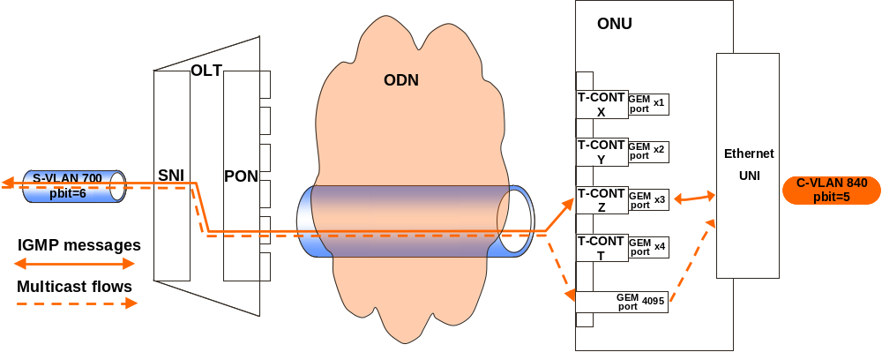  ONU_{3rd}  Test preconditions:  - For this case, vendors have to configure an Ethernet bridge between the OLT and the ONU as described in section 8.2.2, and possibly with the above limitations (see figure above).  - All Multicast TV “channels” have to be configured on the OLT and the ONUs  - Multicast flows definition : see section 8.3.1  - The ONU_{3rd} and ONU_{OLT} are ranged  Test conditions:  - The upstream and downstream frames are VID and p-bit tagged as described in the figure above, ie :  - S-VLAN 700 tagged with a p-bit of 6 on SNI  - C-VLAN 840 tagged with a p-bit of 5 on UNI  - Bidirectional IGMP messages use GEM port x3 and T-CONT Z  - Downstream Multicast flow use multicast GEM port (4095)  - Multicast operation profile (G.984.4 section 9.3.27)  - IGMP snooping at the ONU,  - Immediate leave,  - Limitation of the IGMP upstream rate (the maximum number of IGMP messages is limited to 16 messages per second).  - Channels A, C, D, E are allowed on the ONU_{3rd} (Dynamic access control list table)  - Channels A, B, C, D, E are allowed on the ONU_{OLT} (Dynamic access control list table)  - Multicast properties (G.984.4 section 9.3.28)  - The maximum Multicast bandwidth is set at 24Mbit/s  - the maximum simultaneous multicast groups is set at 2 (ONU side, cf. TR-156 R-97)
Test Procedure | - for each Channels A, C, D, E (allowed on the ONU_{3rd}):  - if necessary, initiate leave on the previous used channel  - then initiate join on the next channel at stake  - Each Multicast TV channel must be available at the ONU side, and each flow must be received with correct p-bits values.  - Verify that no traffic interruption happened on the ONU_{OLT}
OMCI Procedure Details
Pass/Fail Criteria | Test is “Pass” if all allowed Multicast TV channel are available at the ONU side, and if each of these flows are received with the correct p-bits value.  Note that no traffic interruption shall be observed between OLT and ONU_{OLT} during the test (test is “Fail” otherwise).
Remarks

TC5 – Mcast – IGMP Channel Conditional access (allowed channels)
Mcast – IGMP Channel Conditional access (allowed channels)
Test Name | Mcast – IGMP Channel Conditional access (allowed channels)
Test Definition ID | tbd
Reference Document | G.984.4 section 9.3.29
Test Type | IOP
Test Status | Mandatory
Unit Under Test | OLT & ONU
Requirement Description | tbd
Test Objective | This test case aims at verifying that the ONU_{3rd} can only access to the channels belonging to its group, also, authorized in its dynamic access control list table
Test Configuration | Test setup:  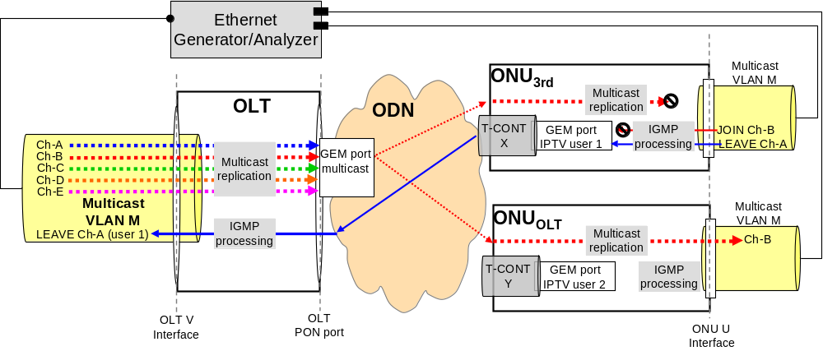  Test preconditions:  - The ONU_{3rd} and ONU_{OLT} are ranged  - Multicast flows definition : see section 8.3.1.  Test conditions:  - No channel is activated on ONU_{OLT} and ONU_{3rd}  - Multicast operation profile (G.984.4 section 9.3.27)  - IGMP snooping at the ONU,  - Immediate leave,  - Limitation of the IGMP upstream rate (the maximum number of IGMP messages is limited to 16 messages per second).  - Channels A, C, D, E are allowed on the ONU_{3rd} (Dynamic access control list table)  - Channels A, B, C, D, E are allowed on the ONU_{OLT} (Dynamic access control list table)  - Multicast properties (G.984.4 section 9.3.28)  - The maximum Multicast bandwidth is set at 24Mbit/s  - the maximum simulataneous multicast groups is set at 2 (ONU side, cf. TR-156 R-97)
Test Procedure | - On the ONU_{3rd} customer 1, ask the channel A  - On the ONU_{OLT} customer, ask the channel B  - With the ONU_{3rd} customer 1, leave the channel A and ask the Channel B  - Check that "join ch-B" IGMP message send by customer 1 does not leave the ONU_{3rd}  - Check that channel B is not received on the ONU_{3rd}  - Check that channel B is still received on the ONU_{OLT}
OMCI Procedure Details
Pass/Fail Criteria | Test is "Pass" if "Join Ch-B" does not leave the ONU_{3rd} and the ONU_{3rd} cannot receive Channel B  Note that Channel B must still be received on the ONU_{OLT} , otherwise test is “Fail”.
Remarks

TC6 – Mcast – Channel Conditional access (Limited number of channels)
Mcast – IGMP Channel Conditional access (Limited number of channel)
Test Name | Mcast – IGMP Channel Conditional access (Limited number of channel)
Test Definition ID | tbd
Reference Document | G.984.4 section 9.3.29
Test Type | IOP
Test Status | Mandatory
Unit Under Test | OLT & ONU
Requirement Description | tbd
Test Objective | This test case aims at checking the ONU_{3rd} availability to block the asked channel if the number of multicast channels is greater than the total number of channels the customer can access
Test Configuration | Test setup:  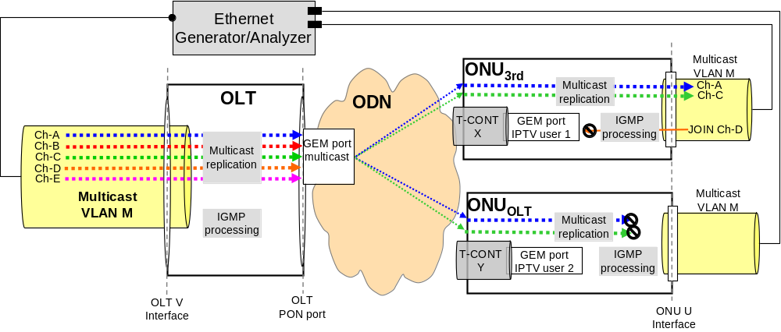  Test preconditions:  - The ONU_{3rd} and ONU_{OLT} are ranged  - Multicast flows definition : see section 8.3.1.  Test conditions:  - Multicast operation profile (G.984.4 section 9.3.27)  - IGMP snooping at the ONU,  - Immediate leave,  - Limitation of the IGMP upstream rate (the maximum number of IGMP messages is limited to 16 messages per second).  - Channels A, C, D, E are allowed on the ONU_{3rd} (Dynamic access control list table)  - Channels A, B, C, D, E are allowed on the ONU_{OLT} (Dynamic access control list table)  - Multicast properties (G.984.4 section 9.3.28)  - The maximum Multicast bandwidth is set at 24Mbit/s  - the maximum simulataneous multicast groups is set at 2 (ONU side, cf. TR-156 R-97)  - the ONU_{OLT}, Channel B is activated  - No Channel is activated on ONU_{3rd}
Test Procedure | - On the ONU_{OLT}, leave Ch-B  - On the ONU_{3rd}, activate the channel A for customer 1 and the channel C for customer 2  - Ask the current multicast bandwidth (ONU counter)  - Consult to the active group list table  - On the ONU_{3rd}; activate the channel D for customer 3 (access MUST be denied)  - Check that Ch-D is not received on the ONU_{3rd}, and Ch-A and Ch-C are always received on the customer 1 and customer 2 respectively.  - Check that Ch-A and Ch-C are not received on the ONU_{OLT}
OMCI Procedure Details
Pass/Fail Criteria | Test is "Pass" if  - "Join Ch-D" does not leave the ONU_{3rd} and  - the ONU_{3rd} cannot receive Channel D and  - Ch-A and Ch-C are always received on the customer 1 and customer 2 respectively and are not received on the ONU_{OLT}
Remarks

TC7 – Mcast – IGMP Channel Conditional access (Bandwidth)
Mcast – IGMP Channel Conditional access (Bandwidth)
Test Name | Mcast – IGMP Channel Conditional access (Bandwidth)
Test Definition ID | tbd
Reference Document | G.984.4 section 9.3.29
Test Type | IOP
Test Status | Mandatory
Unit Under Test | OLT & ONU
Requirement Description | tbd
Test Objective | This test case verifies the ONU_{3rd} capability to block the selected channels if in this case, the multicast customer bandwidth is greater than the fixed limitation
Test Configuration | Test setup:  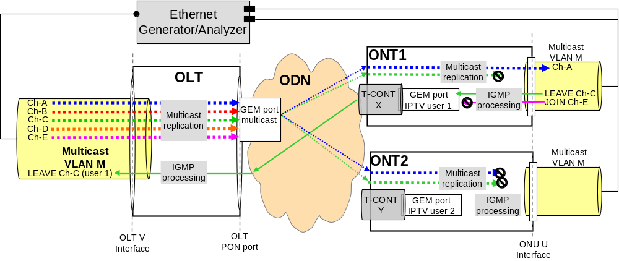  Test preconditions:  - The ONU_{3rd} and ONU_{OLT} are ranged  - Multicast flows definition : see common section 8.3.1.  Test conditions:  - Multicast operation profile (G.984.4 section 9.3.27)  - IGMP snooping at the ONU,  - Immediate leave,  - Limitation of the IGMP upstream rate (the maximum number of IGMP messages is limited to 16 messages per second).  - Channels A, C, D, E are allowed on the ONU_{3rd} (Dynamic access control list table)  - Channels A, B, C, D, E are allowed on the ONU_{OLT} (Dynamic access control list table)  - Multicast properties (G.984.4 section 9.3.28)  - the maximum simulataneous multicast groups is set at 2 (ONU side, cf. TR-156 R-97)  - For this specific test, the following Bandwidth Conditional Accesss shall be configured for ONU_{3rd} :  - Max Allowed Bandwidth = 25 Mbps  - On the ONU_{3rd}, channel A on customer 1 and C on customer 2 are activated  - No Channel is activated on ONU_{OLT}
Test Procedure | On the ONU_{3rd}:  - Ask the current multicast bandwidth (ONU counter)  - Leave Ch-C on customer 2  - Check that Ch-C is not received by customer 2  - Ask the current multicast bandwidth (ONU counter)  - Ask Ch-E on customer 2 (access MUST be denied)  - Check that Ch-E is not received by customer 2  - Ask the current multicast bandwidth (ONU counter)
OMCI Procedure Details
Pass/Fail Criteria | Test is "Pass" if the ONU blocks the channel when the multicast bandwidth is greater than limitation
Remarks

TC8 – Mcast – IGMP counters
Mcast – IGMP counters
Test Name | Mcast – IGMP counters
Test Definition ID | tbd
Reference Document | G.984.4 section 9.3.29
Test Type | IOP
Test Status | Mandatory
Unit Under Test | OLT & ONU
Requirement Description | tbd
Test Objective | This test case verifies the ONU_{3rd} capability to deliver IGMP counters (current multicast bandwidth, IGMP join messages counter, active group list table)
Test Configuration | Test setup: same as above.  Test preconditions:  - The ONU_{3rd} is ranged  - Multicast flows definition : see section 8.3.1.  - Only one IGMP client (Customer 1) is used  Test conditions:  - Multicast operation profile (G.984.4 section 9.3.27)  - IGMP snooping at the ONU,  - Immediate leave,  - Limitation of the IGMP upstream rate (the maximum number of IGMP messages is limited to 16 messages per second).  - Channels A, C, D, E are allowed on the ONU_{3rd} (Dynamic access control list table)  - Channels A, B, C, D, E are allowed on the ONU_{OLT} (Dynamic access control list table)  - Multicast properties (G.984.4 section 9.3.28)  - The maximum Multicast bandwidth is set at 24Mbit/s  - the maximum simulataneous multicast groups is set at 2 (ONU side, cf. TR-156 R-97)  - No channel is activated on ONU_{OLT} and ONU_{3rd}
Test Procedure | - On ONU_{3rd} Activate only one channel (HD channel E)  - Ask the current multicast bandwidth (ONU counter), reports retrieved information in the table below  - Ask active group list table (ONU counter), reports retrieved information in the table below  - Ask join messages counter (ONU counter), reports retrieved information in the table below  - Change the channel (SD channel C or D)  - Ask the current multicast bandwidth (ONU counter), reports retrieved information in the table below  - Ask join messages counter (ONU counter), reports retrieved information in the table below  - Ask active group list table (ONU counter), reports retrieved information in the table below
OMCI Procedure Details
Pass/Fail Criteria | Test is “Pass” if ONU gives access to all the parameters, and reports correct results.
   | Current multicast BW | Join message counter | Active group list table
  HD channel
  SD channel
Remarks

Optional tests cases

TC9 – OPT – ONU software upgrade
ONU software upgrade
Test Name | ONU software upgrade
Test Definition ID | tbd
Reference Document | G.984.4 section 9.1.4  G.984.4 section I.2.7
Test Type | IOP
Test Status | Mandatory
Unit Under Test | OLT & ONU
Requirement Description | tbd
Test Objective | The test case check that the OLT is able to upgrade an ONU software
Test Configuration | Test setup:  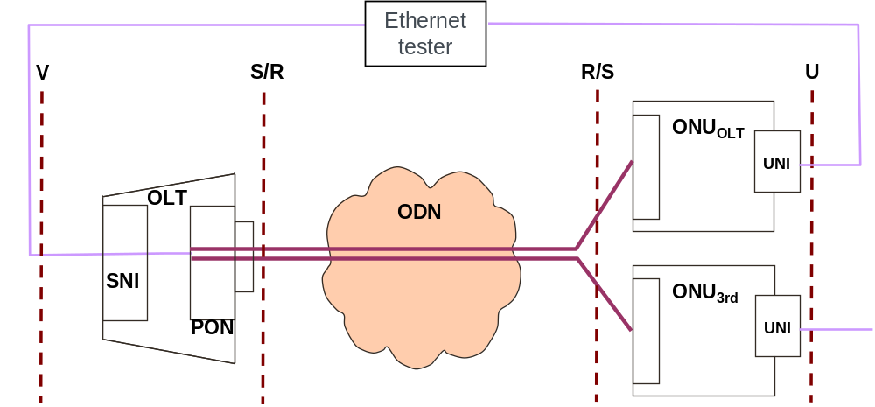  Test preconditions:  The ONU_{3rd} is ranged  ONU_{OLT} has to be connected and traffic has to be generated on it  Test conditions:
Test Procedure | - Download a new software version (a valid image) towards the ONU_{3rd}  - Verify the attributes of the new software image (not active, not committed and valid)  - Activate the new software image  - After the ONU_{3rd} rebooted, verify the two ME software image states (only if possible)  - After the successfully ONU restart on the new software image, verify that Commit software image is send (automatically or manually) by the OLT  - Verify that no traffic interruption happened on the ONU_{OLT}
OMCI Procedure Details
Pass/Fail Criteria | Test is "Pass":  - if the OLT can download the new image software and  - it the new software image is valid and  - it the OLT can activate the new image software and  - if after the reboot the new software is active and  - if ONU_{3rd} can commit the new image software and  - If there is no traffic interruption on the ONU_{OLT}
Remarks

TC10 – OPT – MIB and alarm Synchronisation

TC10 – OPT – MIB Synchronisation

MIB Synchronisation
Test Name | MIB Synchronisation
Test Definition ID | tbd
Reference Document | G.984.4 section 9.1.3  G.984.4 section I.2
Test Type | IOP
Test Status | Optional
Unit Under Test | OLT & ONU
Requirement Description | tbd
Test Objective | This test case verifies the MIB synchronization capability of the ONU_{3rd}
Test Configuration | Test setup:  Test preconditions:  - ONU_{3rd} is ranged  - ONU_{OLT} has to be connected and traffic has to be generated on it.  Test conditions:
Test Procedure | - Disconnect the Optical fibre  - Wait 30s or 1min and then reconnect the Optical fibre  - The OLT must send a GET ONT data to check the MIB synchronization  - If the OLT and the ONU are synchronized there is no MIB upload, and if it is not the case, they have to synchronize. The MIB synchronisation must follow the OMCI Implementer's guide V2 section 8.2.1.4  - Verify that no traffic interruption happened on the ONU_{OLT}
OMCI Procedure Details | n/a
Pass/Fail Criteria | Test is “Pass”  - if the MIB synchronization can be verified and  - if the MIB is synchronized and  - if no traffic interruption happened on the ONU_{OLT}
Remarks

TC11 – OPT – Alarms Synchronisation

Alarms Synchronisation
Test Name | Alarms Synchronisation
Test Definition ID | tbd
Reference Document | G.984.4 section 9.1.3  G.984.4 section I.3
Test Type | IOP
Test Status | Optional
Unit Under Test | OLT & ONU
Requirement Description | tbd
Test Objective | This test case verifies the Alarms synchronization capability of the ONU_{3rd}
Test Configuration | Test setup:  Test preconditions:  - ONU_{3rd} is ranged  - ONU_{OLT} has to be connected and traffic has to be generated on it.  - An Ethernet link is Up onto the UNI interface of the ONU_{3rd}  Test conditions:
Test Procedure | - Disconnect the optical fibre  - Disconnect the Ethernet cable from the UNI interface of ONU_{3rd}  - Wait between 30s and 1 min and then reconnect the optical fibre  - The OLT must send GET ONT DATA and then a GET ONT ALL ALARMS  - As ONU_{3rd} alarms (at least 1 UNI disconnection), the ONU_{3rd} will answer with the numbers of instance that are required to retrieve the active alarms  - The OLT has to send N GET ALL ALARMS NEXT (number of commands, cf. section 8.2.2 of the OMCI implementers’ Guide)  - Verify that no traffic interruption happened on the ONU_{OLT}
OMCI Procedure Details | n/a
Pass/Fail Criteria | Test is “Pass”  - if alarms synchronization has been verified and  - if alarms are synchronized and  - if the process follows the OMCI implementers’ Guide and  - if no traffic interruption happened on the ONU_{OLT}
Remarks

TC12 – OPT – Provisioning using Registration ID method (wrong Reg-ID case)
ONU Provisioning according to the registration-ID (wrong Reg-ID case)
Test Name | ONU Provisioning according to the registration-ID (wrong Reg-ID case)
Test Definition ID
Reference Document | - BBF TR-156 Section 7.2  - ITU-T G. 984.3 Section 10 and Annex A.6  - ITU-T G.984.3 Amd1 Sections 2.2 and 2.3
Test Type | Interoperability
Test Status | Optional
Unit Under Test | OLT and ONU
Requirement(s)  Description | ITU-T G.984.3 Amd1:  - Sections 2.2 and 2.3, test of the ONU activation according to the registration-ID
Test Objective | The purpose of this test is to verify:  - that the ONU can reach the state O5 using the registration-ID mechanism  - the ONU is deactivated by OLT when a wrong Reg-ID is sent by the ONU
Test Configuration | Test Setup:  Preconditions:  - The OLT MUST be compliant with the requirements WT-247 R-151and R-155 (cf. dedicated OLT and ONU conformance tests),  - The ONU MUST be compliant with the requirement WT-247 R-152 (cf. dedicated OLT and ONU conformance tests)  - The ONU is always powered on  Test Conditions:  - A remote access (CLI or EMS) to the OLT MUST be available
Test Procedure | - Pre-provision the ONU_{3rd} with the dedicated registration-ID at the OLT  - Via a local interface, enter at the ONU the wrong registration-ID  - Connect the ONU_{3rd} to the ODN, which shall range after 30 s [time reference defined in the ITU-T Serie G, Supplement 46]  - Wait for registration-id is confirmed by ONU with a wrong value  - Check that ONU is deactivated by OLT.
PLOAM / OMCI Procedure Details
Pass/Fail Criteria | The test is "PASS":  - If O5 state is achieved and  - if the ONU is deactivated by OLT following the wrong Reg-ID is sent by the ONU
Remarks

Blindfold pairing tests

Principle
The purpose of blindfold pairing is to verify that an OLT is able to configure service architecture for different ONTs vendors with unique sequence of CLI commands or a batch mode file given by the OLT vendors to the lab technical manager.
During one of each official pairings session
- An OLT vendor will be chosen (this OLT vendor will not be active on any pairing of the official test session). The other OLT vendors will be involved in the active official test sessions.
- ONT vendors taking part into the blindfold pairings are ONT which are not involved in the active official test sessions (Idle ONT vendors)
- At the end of the Blindfold test session, if there is some time left before end of the test session, the OLT vendor will be asked to go on with the official test using the ONT that was planned in the official test schedule.
- A single service architecture is tested using a PC based architecture :
  - A PC equipped with 1000BASE-SX card (Multi-mode optical is used) is acting as a Multicast server generating MULTICAST video streams as per §6.2.1details using VLC (VLC v.1.0.5 Goldeneye for Linux distribution)
  - another PC is acting as a Multicast client using VLC (VLC v.1.0.5 Goldeneye for Linux distribution)
- Only one VLAN is used
OLT
ONU_{3rd}
ODN B+
(attenuators
,
fiber
…
)
MCAST Server
(1000BASE-SX)
MCAST Client
- All OLT vendors have to provide a unique OLT configuration procedure (Sequence of necessary CLI commands or a batch mode file) to the organizer
  - Add a new ONU : this sequence must include all steps of the configuration process including the provisioning process using the registration-id method
  - Create and configure all needed Manage Entities especially for the management of multicast streams and support of IGMP such as described in the Blindfold test case (see blindfold test case below) : number of authorized channels, bandwidth, multicast groups.
  - Create architecture described in test case 8.3.1
  - Remove the ONU : This sequence must include all steps of the configuration process to erase an ONT configuration.
- During the pairing :
  - The Lab technical manager will play this configuration sequence by himself (without any vendors team intervention)
  - The OLT under test will be tested in front of different ONTs

Blindfold pairing test case

BF - Availability of Multicast traffic on the ONUs and Zapping tests

BF - Availability of Multicast traffic on the ONUs and Zapping tests
Test Name | BF - Availability of Multicast traffic on the ONUs and Zapping tests
Test Definition ID | tbd
Reference Document
Test Type | IOP
Test Status | Mandatory
Unit Under Test | OLT & ONU
Requirement Description | tbd
Test Objective | The objective of this test is to verify that all channels are available and can be “displayed” / received on the ONU_{3rd} and to verify that zapping between different IPTV channels is OK.
Test Configuration | Test setup:  - The blindfold pairing tests is conducted using on a PC-based architecture having the characteristics as described in the above section 9.1  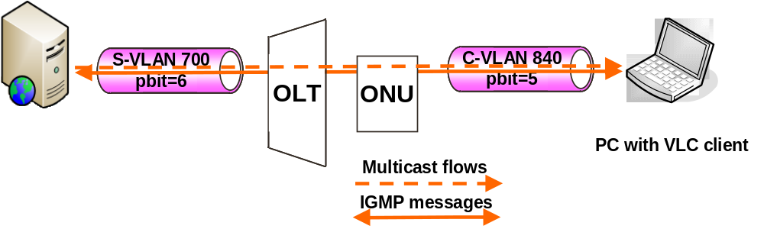  Test preconditions:  - Multicast flows definition : see section 8.3.1  - OLT vendors has to provide a unique OLT configuration procedure (Sequence of necessary CLI commands or a batch mode file) to the organizer  - To add a new ONT : this sequence must include all steps of the configuration process including the provisioning process using the registration-id method  - To delete an ONT : this sequence must include all steps to erase an ONT configuration  Test conditions:  - The upstream and downstream frames are VID and p-bit tagged as described in the figure above, ie :  - S-VLAN 700 tagged with a p-bit of 6 on SNI  - C-VLAN 840 tagged with a p-bit of 5 on UNI  - Bidirectional IGMP messages use GEM port x3 and T-CONT Z  - Downstream Multicast flow use multicast GEM port (4095)  - Multicast operation profile (G.984.4 section 9.3.27)  - IGMP snooping at the ONU,  - Immediate leave,  - Limitation of the IGMP upstream rate (the maximum number of IGMP messages is limited to 16 messages per second).  - Channels A, C, D, E are allowed on the ONU_{3rd} (Dynamic access control list table)  - Multicast operation profile (G.984.4 section 9.3.28)  - The maximum Multicast bandwidth is set at 12 Mbit/s  - The maximum simultaneous multicast groups is set at 2 (ONU side, cf. TR-156 R-97)
Test Procedure | - The ONU_{3rd} can ranged correctly  - Then Test Procedure from test case TC3-4 (see section 8.3.2) is applied  - Check that Channel B cannot be displayed (not allowed channel)  - Check that Channel E cannot be displayed (bandwidth limitation)
OMCI Procedure Details
Pass/Fail Criteria | Test is “Pass”  - if ONU_{3rd} can ranged correctly and  - if all allowed Multicast TV channel are available at the ONU side, and  - if each of these flows are received with the correct p-bits value and  - Channel B cannot be displayed  - Channel E cannot be displayed
Remarks

Event agenda and tests schedule
This section provides an estimated weekly test schedule. The schedule allows for two test sessions per day, except for Monday. There are a total of 8 test sessions throughout the event, of 4.5h duration each and with each test session having at most 8 parallel test pairings (will depend on the effective number of OLTs participating).

Monday | 08.00 | Lab & Registration Opening
 | 08.00 - 11.45 | Set up time + Preliminary Tests (OLTs)
 | 11.45 - 12.15 | Test Event Launch Meeting (all companies)
 | 12.15 - 12.30 | Q&A
 | 12.30 - 13.00 | Welcome reception
 | 13.00 - 14.00 | Lunch
 | 14.00 - 18.30 | Test Session #1 - TS1
 | 19.00 | Closing test room
Tuesday | 8.00 | Room opening
 | 08.30 - 13.00 | Test Session #2 - TS2
 | 13.00 - 14.00 | Lunch
 | 14.00 - 18.30 | Test Session #3 - TS3
 | 19.00 | Closing test room
Wednesday | 8.00 | Room opening
 | 08.30 - 13.00 | Test Session #4 - TS4
 | 13.00 - 14.00 | Lunch
 | 14.00 - 18.30 | Test Session #5 - TS5
 | 19.00 | Closing test room
Thursday | 8.00 | Room opening
 | 08.30 - 13.00 | Test Session #6 - TS6
 | 13.00 - 14.00 | Lunch
 | 14.00 - 18.30 | Test Session #7 - TS7
 | 19.15 | Closing test room
19.30 | 19.30 | Departure for dining event
Friday | 8.00 | Room opening
 | 08.00 - 13.00 | Test Session #8 - TS8  Test week wrap up
 | 13.00 - 14.00 | Lunch
 | 14.00 - 15.30 | Equipment break-down

Official test pairings
The OLT and ONU indices will be kept confidential by the hosting Lab. This index is uniquely given to OLT and ONU vendor to address the test event schedule given below. Note : it is not related in anay way to the index from the list of participants given in section 1.

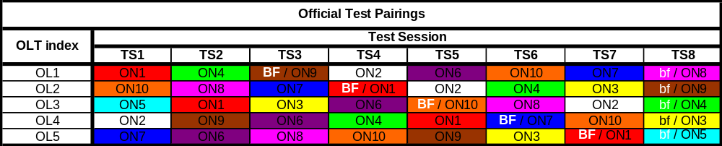

Total of pairings for official tests : 40 pairings
Total of pairings for official tests per ONU : 3+ or 4 pairings

Blindfold test pairings
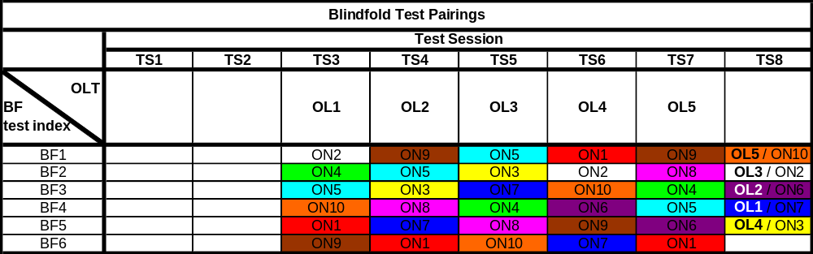

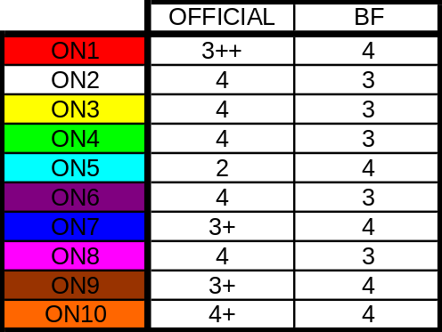

Total of pairings for blindfold tests : 35
Total of pairings for blindfold tests per ONU : 3 or 4

Expected result metrics
- OLT vendors and ONU vendors will have to fill a specific document using the dedicated FTP site 20 minutes before the end of each pairing session.

- The following template file has to be used to report the results :


- Note that some fields can take restricted values, e.g.the verdict of a test case can be :
  - PASS
  - FAIL
  - OOT (out of time)
  - NA (not applicable)

- This file should filled by the OLT and ONU vendors together with the appropriate results and technical comments obtained during the test session.

- Once filled, the file should be named according to the following rule :

  - TS#session_yy-OL#OL_index-ON#ON_index-edzz.xls
  - Example : TS9-OL3-ON9-ed00.xls
  - The edition “ed” number is used in case several version of the file might be generated

- Then it should be uploaded by the OLT vendor on the dedicated FTP site (FTP information is provided to each OLT vendor by the hosting lab at the registration step on Monday morning).

- FTP account information MUST NOT BE SHARED between OLT and ONU vendors.

Annex

Annex 1: Template for test cases

Test Name
Test Name
Test Definition ID | tbd
Reference Document
Test Type | IOP
Test Status | Mandatory
Unit Under Test | OLT & ONU
Requirement Description | tbd
Test Objective
Test Configuration | Test setup:  Test preconditions:  Test conditions:
Test Procedure
OMCI Procedure Details
Pass/Fail Criteria
Remarks

- END OF DOCUMENT -

